Outputs of Program 1

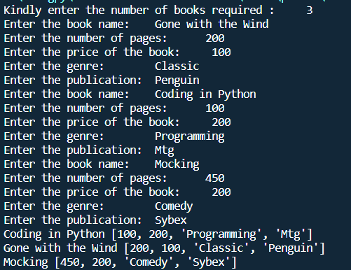

Output of Program 2

